Package :org.college

Class :College

Methods :collegeName(),collegeCode(),collegeRank()

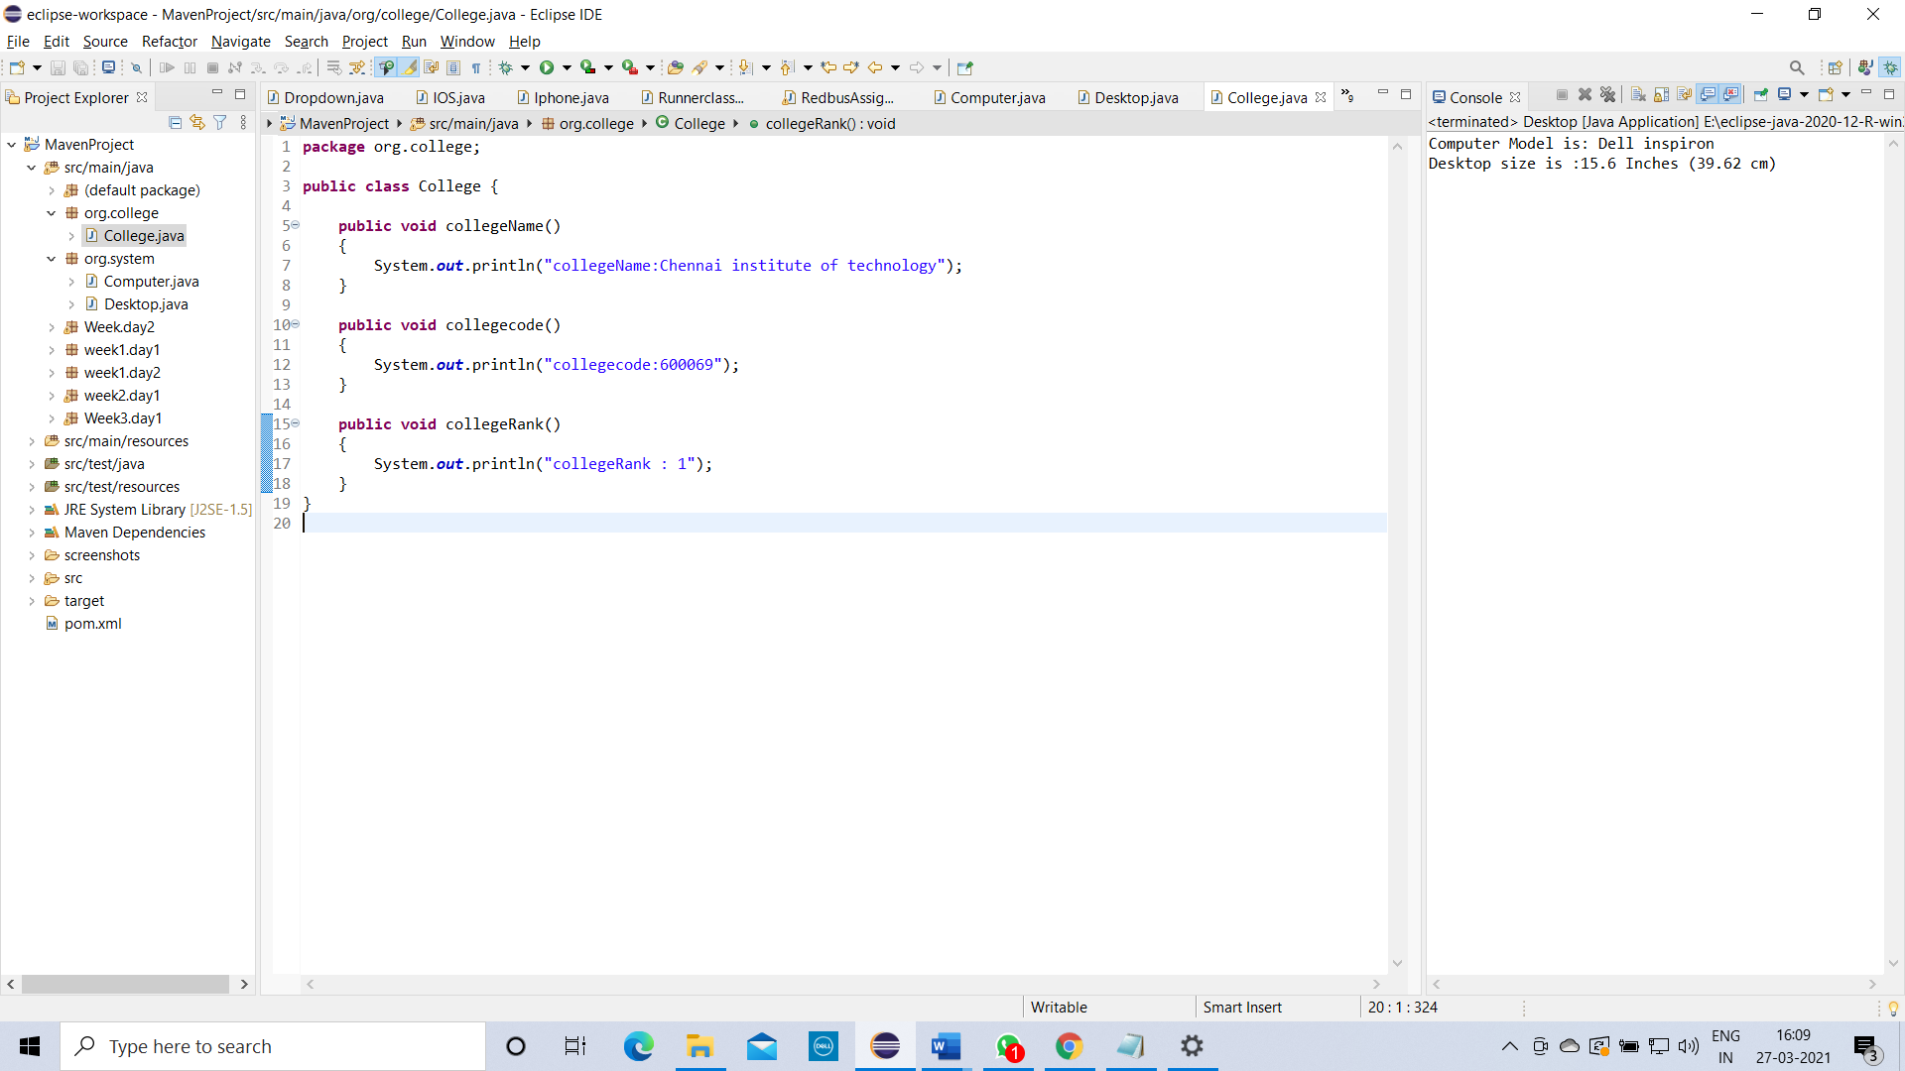

Package :org.department

Class :Department

Methods :deptName()

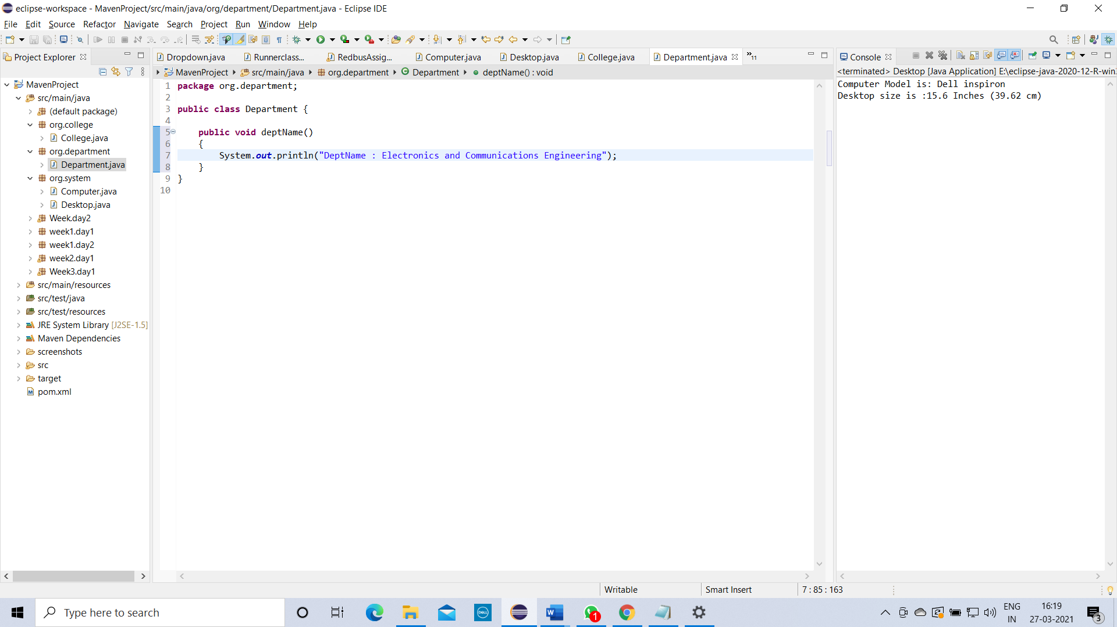

Package :org.student

Class :Student

Methods :studentName(),studentDept(),studentId()

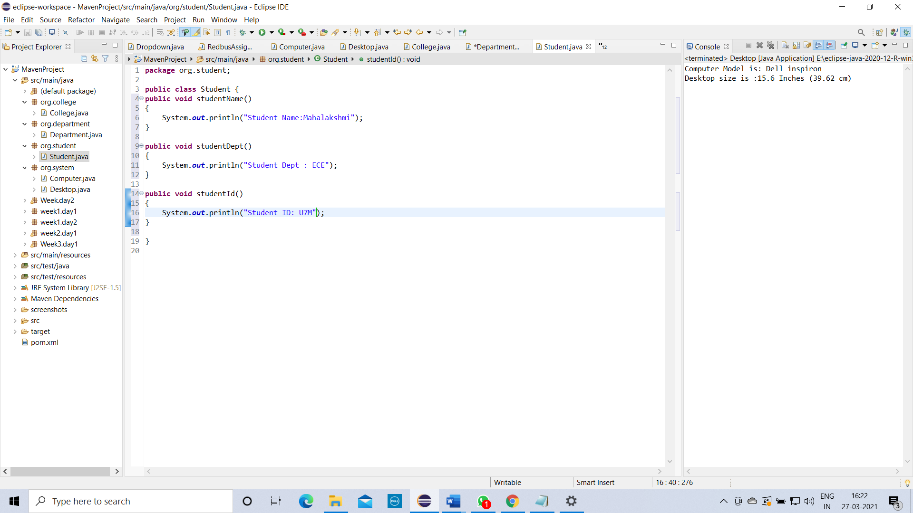

create above 3 class and call all your class methods into the Student using multilevel inheritance.

